Dr.Vinay Kumar,
Dr.med dent, Dr.rer hum,
MDS, DMD (DE), FDS RCS (Ed), MD & PhD (DE)
ITI Fellow (2012),ITI Scholar (2010)
Faculty from Sweden
faculty at sri Shankara & upsala,Oral rehabilitation centre
DEPARTMENT OF ORAL AND MAXILLOFACIAL SURGERY
TAGORE DENTAL COLLEGE AND HOSPITAL
MELAKOTTAIYUR POST, RATHINAMANGALAM
CHENNAI – 600127
PH: 044 – 3010 2222, EXTN: 228 / 230
EMAIL ID: maxfacs@tagoredch.in

PROF.M.MALA DR.VENKATAKRISHNAN
CHAIRPERSON PRINCIPAL

ORGANIZING COMMITTEE:
PROF.DR.S.JIMSON
DR.B.LOKESH
DR.B.ANANDH
DR.BALAKRISHNA
DR.MEERAN SHARIF
DR.VINAY SUNDAR
DR.ISRAEL NATHANAEL
DR.JONES JAYABALAN

Organizer:
Department of Oral & Maxillofacial Surgery
Tagore Dental College & Hospital

Date: 4,5TH AUGUST 2021

Learning Outcome:
- To Acquire detailed knowledge on sinus anatomy , sinus lift procedures , basics in dental implantology and all on 4 implant placement .
- To train students on sinus lift procedure.
- Hands on implant placement.

Guest Speakers:
1. Dr. Vinay V. Kumar
Consultant OMF surgeon
Resource person, Bangalore.

2. Dr.Sameer Ahmed
Consultant OMF surgeon and Organizer
Cowell Medi implants pvt.ltd

TOPICS COVERED :
1. Implant placement –Treatment planning, Soft tissue incisions, Preparation of implant site.
2. Healing Screw, cost effectiveness in dental implants, digital implantology, and post operative care in dental implantology

SCHEDULE
DAY 1
DATE | PROGRAM
8.30 TO 9.00 AM | REGISTRATION
9.00 TO 9.10 AM | WELCOME ADDRESS – Dr.S.Jimson
9.30 TO 11.30 AM | LECTURE- “ BASICS IN SINUS LIFT & DENTAL IMPLANTOLOGY” –Dr.Vinay V.Kumar
11.30 TO 11.45 AM | TEA BREAK
11.45 TO 1.15 PM | SINUS LIFT PROCEDURE –LIVE DMONSTRATION
1.15 TO 2.00 PM | LUNCH BREAK
2 TO 3 .00 PM | ALL ON 4 IMPLANT PLACEMENT –LIVE DMONSTRATION
3 TO 3.30 PM | DISCUSSION
DAY 2
DATE | PROGRAM
9 TO 10.30 | LECTURE- “ BASICS IN IMPANT SCIENCE AND DIGITAL IMPLANTOLOGY“
10.30 TO 10.45 AM | SHORT BREAK
10.45 TO 1.00 PM | HANDS ON –SESSION 1
1.00 TO 1.30 PM | LUNCH
1.30 TO 2.30 PM | HANDS ON –SESSION 2
2.30 TO 3.00 PM | VALEDICTORY SESSION

DAY 1
The program started by 9.00 AM with the welcome speech given by the Organizing chairman Prof.Dr.Jimson. The speakers (Dr.Vinay & Dr.Sameer )were then felicitated by the Principal Prof.Dr.Venkatakrishnan .The first lecture began at 9.30 AM by Dr.Vinay.V.Kumar on the topic “ Basics in sinus lift and dental implantology “it was a detailed lecture which involved the treatment planning and procedural aspects of implant placement .After a 15minutes tea break , the live demonstration of sinus lift was started . It ended by 1.15 PM followed by lunch break. The second live demonstration session started by 2 PM on “All on 4” implant placement and discussion. It was the conclusion for day 1 session.
DAY 2
The day 2 started with a lecture on “digital implantology and cost effectiveness in dental implants “by Dr.Sameer Ahmed. The lecture was followed by a short break. After which, there was the first session of Hands-On on single implant placement.
All the participants were separated into batches and were assigned models and works .The session involved “lateral window preparation “ on STL models and implant placement .Lunch break was observed at 1PM. following the lunch break the session 2 for Hands-on started and it ended by 2.30 PM .
The valedictory function was held 2.30 to 3.00 PM and certificates for participation and certificates for appreciation were handed over to the students and faculty respectively. The day concluded with the vote of thanks given by Prof.Dr.Jimson.

Feedback:
The program was attended by 8 postgraduate students, 10 undergraduate students and 6 faculties.
Overall the program received an excellent feedback from the participants.

PICTURES:
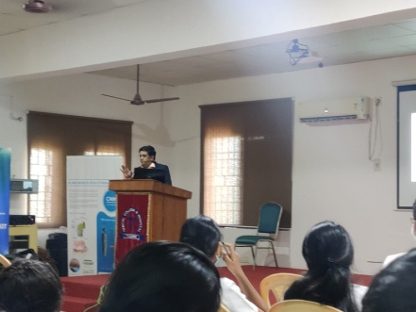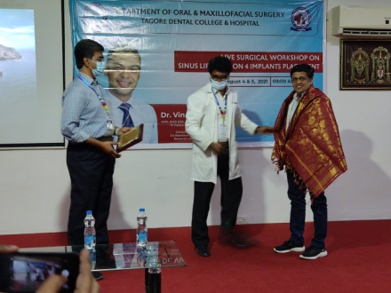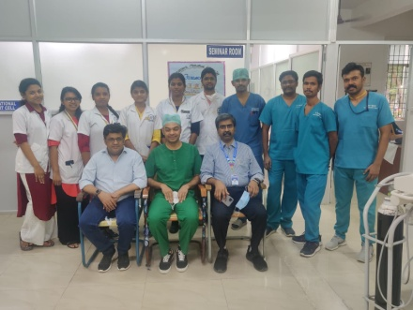

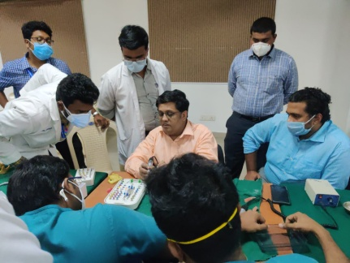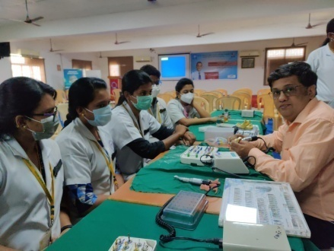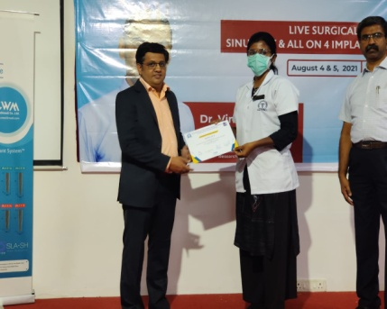

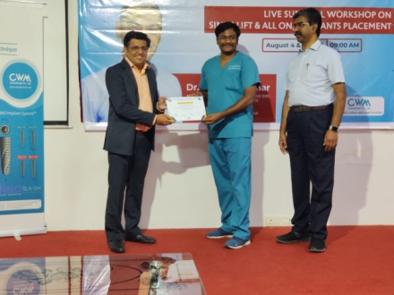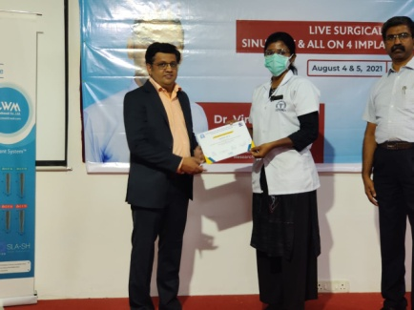

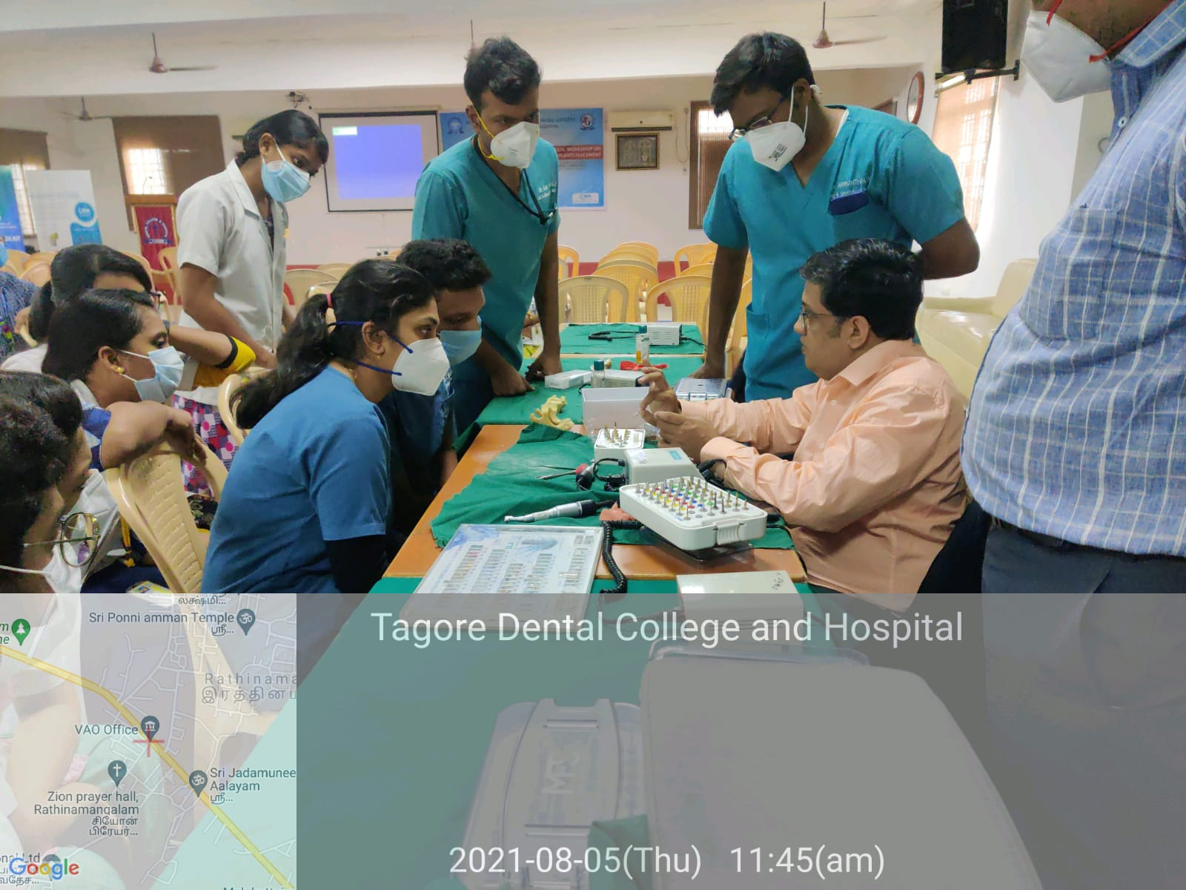

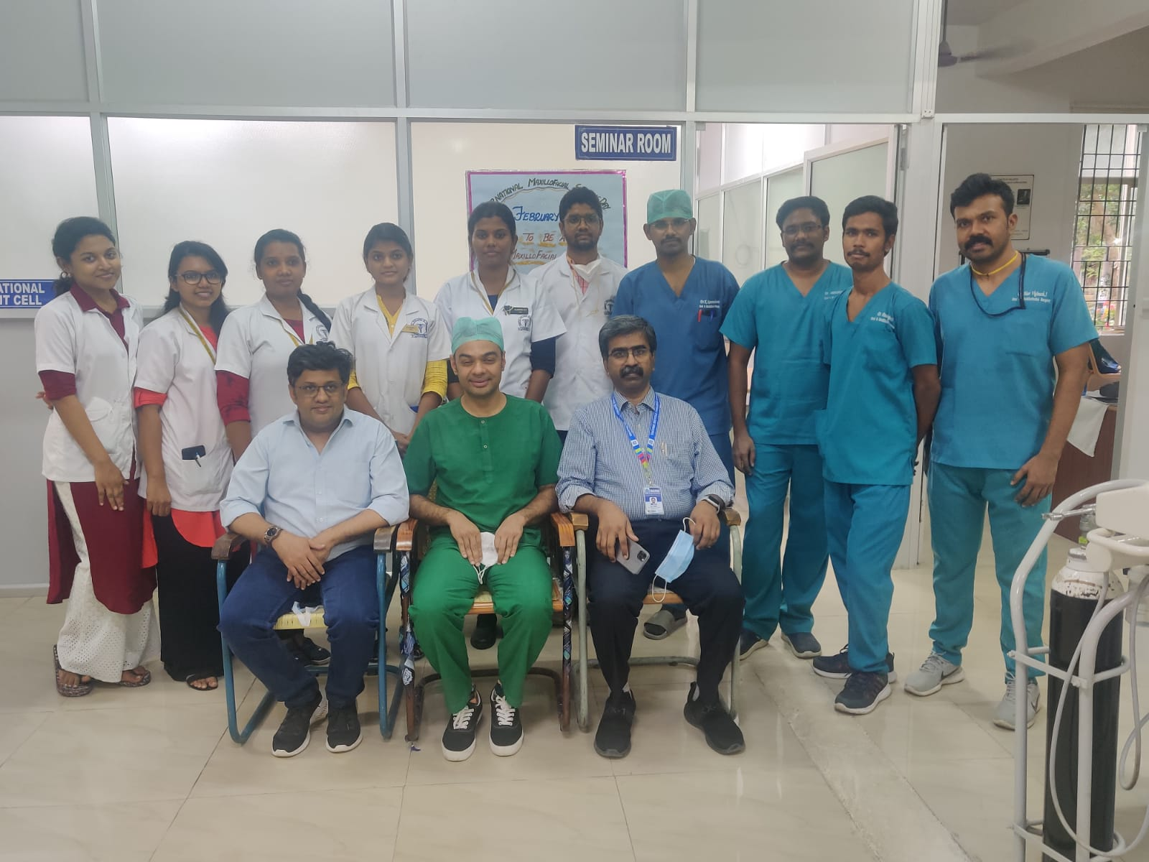
ATTENDANCE SHEET
STUDENTS:
1.DR.RAVEENDHARAN
2. DR.ARRVINTHAN
3. A.M.ROSHINI
4.POORANI.V
5.AKKSHAYA
6.SUDARSHAN
7.BHARGAVI
8.YAZHINI.N.S
9.PANDIYARAJAN
10.HARIVIGHNESH
11.SHANKAR
12.SAHANA RANGARAJAN
FACULTY :
13.DR.S.JIMSON
14.DR.LOKESH
15.DR.ANANDH.B
16.DR.BALAKRISHNA
17.DR.MEERAN SHARIF
18.DR.VINAY SUNDAR
19.DR.ISRAEL NATHANAEL
20.DR.JONES JAYABALAN

